Apache JMeter

walk through running JMeter on Windows for this exact Spring Boot + Prometheus example, step by step

1️⃣ Prerequisites (Windows)
✔ Java
JMeter needs Java (JDK 8+, works fine with JDK 17).
Verify:
java -version
If not installed:
- Download JDK 17 (Temurin / Oracle)
- Set JAVA_HOME
- Add %JAVA_HOME%\bin to PATH

✔ Download Apache JMeter
- Go to: https://jmeter.apache.org/download_jmeter.cgi
- Download Binaries → zip
- Extract to:
C:\tools\apache-jmeter-5.6.3

2️⃣ Start Your Spring Boot App
Make sure the app from the previous example is running:
mvn spring-boot:run
Test:
http://localhost:8080/api/test

3️⃣ Start JMeter (GUI mode – first time)
From Command Prompt (not PowerShell):
cd C:\tools\apache-jmeter-5.6.3\bin
jmeter.bat
JMeter UI opens.

4️⃣ Create the Test Plan (GUI)
A) Test Plan
- File → New
- Rename Test Plan → SpringBoot Load Test

B) Add Thread Group
Right-click Test Plan →
Add → Threads (Users) → Thread Group
Set:
Setting | Value
Number of Threads | 100
Ramp-Up Period | 20
Loop Count | -1 (infinite)
💡 Stop test manually after 3–5 minutes.

C) Add HTTP Request
Right-click Thread Group →
Add → Sampler → HTTP Request
Set:
Field | Value
Protocol | http
Server Name | localhost
Port | 8080
Method | GET
Path | /api/test

D) Add HTTP Header Manager (Optional)
Right-click HTTP Request →
Add → Config Element → HTTP Header Manager
Add:
Content-Type: application/json

E) Add Timers (Important for Stable RPS)
Constant Throughput Timer
Right-click Thread Group →
Add → Timer → Constant Throughput Timer
Set:
Field | Value
Target Throughput | 30000
Calculate Throughput | All active threads
30000 / 60 = 500 RPS

F) Add Listeners
1️⃣ Summary Report
Right-click Thread Group →
Add → Listener → Summary Report
2️⃣ Aggregate Report
Right-click Thread Group →
Add → Listener → Aggregate Report

5️⃣ Run the Test (GUI)
Click ▶ Start
Watch:
- Throughput → RPS/TPS
- 95% Line → p95 latency
- Error % → must be < 1%

6️⃣ Run JMeter in NON-GUI Mode (Recommended)
GUI is for setup only. Use non-GUI for real tests.

A) Save Test Plan
File → Save As → springboot-load-test.jmx

B) Run Non-GUI
1) cd C:\tools\apache-jmeter-5.6.3\bin>jmeter.bat -n -t "C:\test\SpringBoot Load Test.jmx" -l C:\test\results.jtl -e -o C:\test\report

OR

2) cd C:\tools\apache-jmeter-5.6.3\bin>jmeter.bat -n -t "C:\test\SpringBoot Load Test.jmx" -l C:\test\results.jtl
3) cd C:\tools\apache-jmeter-5.6.3\bin>jmeter.bat -g C:\test\results.jtl -o C:\test\report

if html file not generate:
Add in jmeter.properties file
jmeter.save.saveservice.output_format=csv
jmeter.save.saveservice.print_field_names=true

jmeter.save.saveservice.time=true
jmeter.save.saveservice.elapsed=true
jmeter.save.saveservice.label=true
jmeter.save.saveservice.response_code=true
jmeter.save.saveservice.response_message=true
jmeter.save.saveservice.thread_name=true
jmeter.save.saveservice.data_type=true
jmeter.save.saveservice.success=true
jmeter.save.saveservice.failure_message=true
jmeter.save.saveservice.bytes=true
jmeter.save.saveservice.sent_bytes=true
jmeter.save.saveservice.grp_threads=true
jmeter.save.saveservice.all_threads=true
jmeter.save.saveservice.latency=true
jmeter.save.saveservice.connect_time=true
jmeter.save.saveservice.assertions=true

then stop 2 and run 3

C) Open HTML Report
C:\tests\report\index.html
This gives:
- RPS
- p95 / p99 latency
- Error %
- Throughput over time

7️⃣ Mapping Metrics to Your SLA
Requirement | Where to Check
RPS / TPS | Summary Report → Throughput
Concurrent users | Thread Group
p95 < 500 ms | Aggregate Report → 95% Line
Error rate < 1% | Error %
CPU / Memory | Grafana
JVM threads | Grafana

8️⃣ Common Windows Issues & Fixes
❌ java.lang.OutOfMemoryError
Increase heap:
set HEAP=-Xms1g -Xmx1g
jmeter.bat

❌ Firewall Blocking
Allow:
- java.exe
- Port 8080
- Port 9090 (Prometheus)

❌ Low Throughput
- Increase threads
- Increase ramp-up
- Run JMeter on a different machine if possible

9️⃣ Typical Load Test Run Order (Windows)
- Start Spring Boot
- Start Prometheus
- Start Grafana
- Run JMeter (non-GUI)
- Observe Grafana dashboards

how to read p95 / p99 / throughput properly
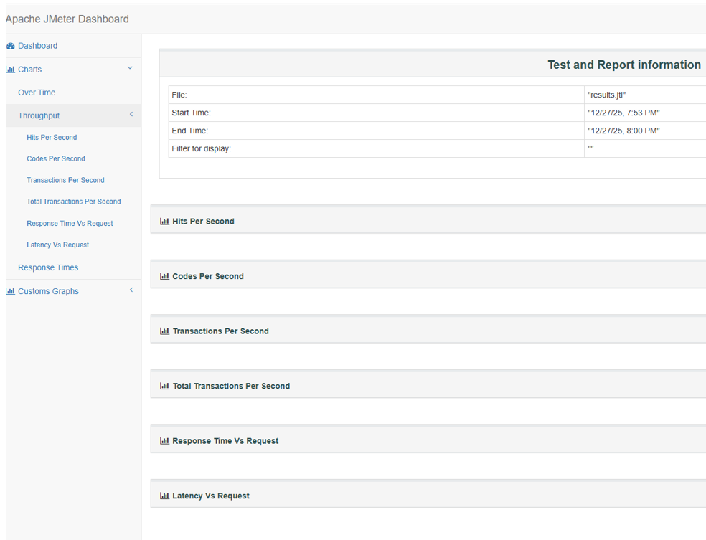

2️⃣ Throughput (left menu → Throughput / Hits Per Second)

4️⃣ p95/P99 — how to read it correctly
P95: HTTP Request 90.00 percentile was 189ms
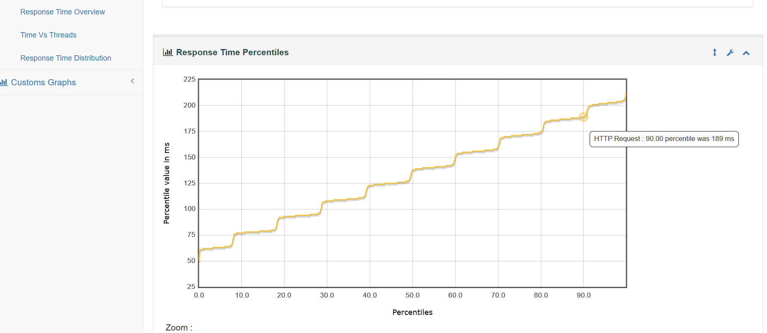

P99: HTTP Request 99.00 percentile was 204ms
